1. Copy “UeAmendment.app” file to Main folder (i.e. USquare / iTax folder)

2. Copy the below files to company folder
a. UeTrigVouInit.prg
b. UeTrigVouAftActivate.prg
c. UeTrigVouNew.prg
d. UeTrigVouCancel.prg
e. UeTrigVouBefEdit.prg
f. UeTrigVouAftEdit.prg
g. UeTrigVouFinalUpdate.prg
h. UeTrigVouToolSave.prg
i. UeTrigActivate.prg

3. Run the "Structure & data Script.sql" in company database this will activate the amendment process for "Sales Order and Purchase Order".

3. Run the "Report Patches.sql" in company database. This will activate the "Amendment Report".

4. Create the menu per given in below picture file.
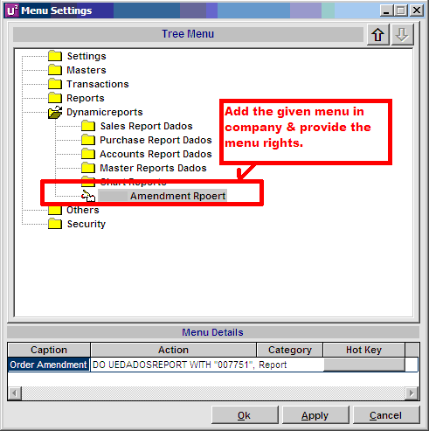

5. Please re-compile the all PRG files

6. After menu Creation please logged Out from Software

7. Re Login in software and assign menu rights to new created menu which was mentioned in above picture

